Step 1: Go to <https://www.everettsd.org/Page/1>

Step 2: On the home page click the Enrollment button.



Step 3: Click the General Enrollment button.

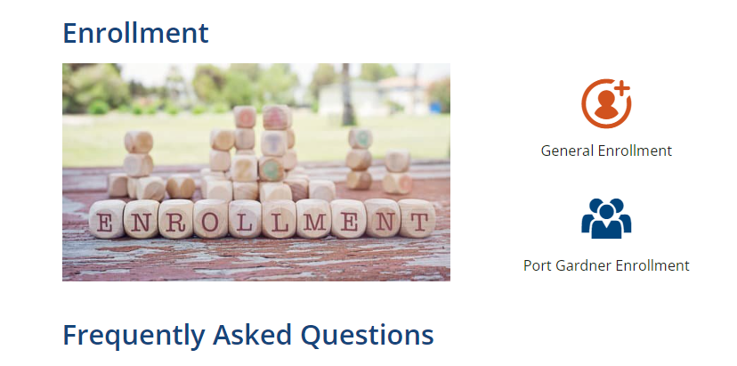

Step 4: Make sure you have a Proof of Address Document and Immunization Records. **Enrollments cannot be processed without a Proof of Address.** You must have an immunization record from your Dr. or a Washington State Immunizations Information System <http://waiis.doh.wa.gov/> **. Students will not be able to start school on the first day if they are missing any required immunizations.** If you are enrolling in Washington State for the first time, please upload a Proof of Age (Birth Certificate/Passport/Etc.)

Step 5: Click the Enroll Online blue tab which will prompt you to create an account and login.

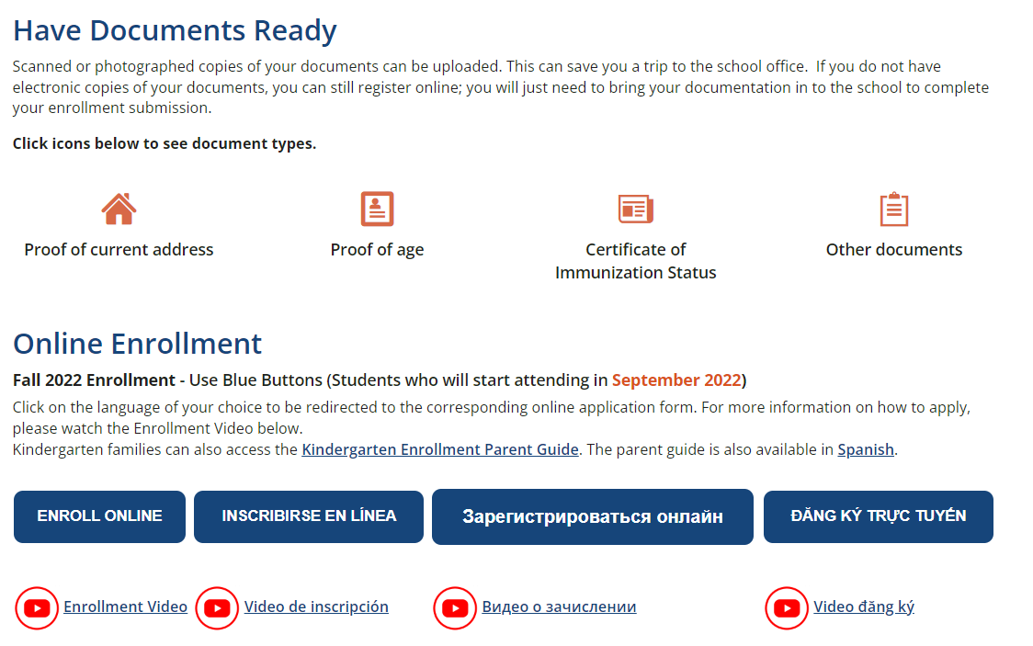

Step 6: Create your account and answer all enrollment questions. Don’t forget to upload the required documentation. You can also upload helpful information for scheduling purposes like a report card, progress report etc.

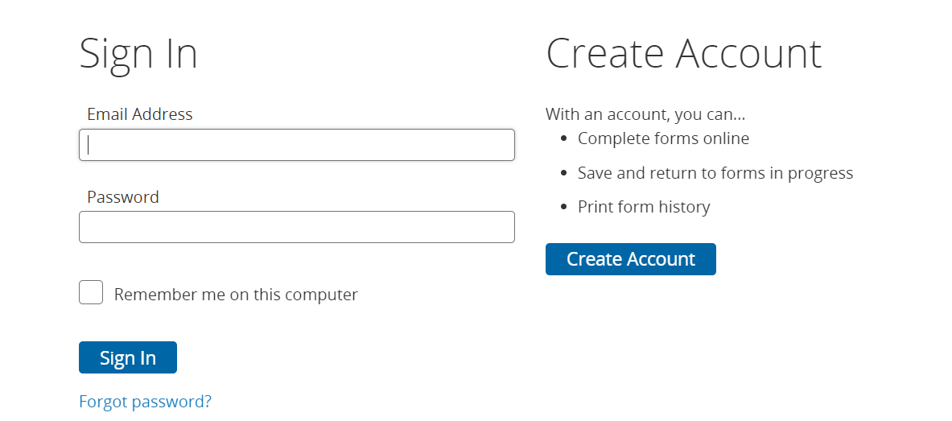

Step 7: After you have submitted and received a confirmation email you are set. The Registrar will be processing them before 6/29/22 and after 8/17/22.

*You must complete an enrollment for each student with attachments.

Registrar:

Colleen Bledsoe

[cbledsoe@everettsd.org](mailto:cbledsoe@everettsd.org)

425-385-7510